Tennessee Valley Civil War Round Table

March 2017 Newsletter
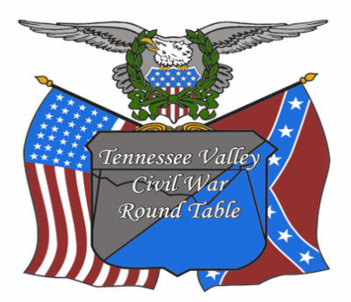

To Inform and Educate Since 1993 Contents

Last chance to renew your membership; your membership guarantees great speakers and other Civil War adventures.

Go to www.tvcwrt.org and use Pay Pal, or see Kevin Thursday.

President’s Message:

2. John Mason, speaks

Announcements:

3. February Speaker: Dr. John Marszalek “Sherman: Myth & Reality
4. Remembering Brian Hogan; Former President of the TVCWRT
5. Board Vacancies (Don’t be afraid, Step up)
7. Renee´ Pruitt Annual Award Luncheon
7. Beer, Bourbon, and BBQ Festival
7. Huntsville Historical Society General Membership Meeting
8. Jim Ogden Award Presentation
8. The 2017 Photo Contest: Don’t be shy-participate
9. The TVCWRT Approved Reading List; take a look

TVCWRT Features
9. Board Reports
Programs: Acting Program Officer John Scales
Membership: Kevin Rodriguez

10 Book Review
Lincoln’s Great Journey reviewed by Ricardo Jaramillow
11. Little Round Table Report
11. 2017 Little Round Table Topic Schedule

President’s Message

So, spring is finally in the air. Yes, the temperatures of late have been a dead give-away, but I have an even better way of telling. It may only be the first of March, but my eyes and nose recognize pollen when they feel it. But on to bigger and better things . . .
Last month’s presentation, Bottom Rail on Top by yours truly seemed to have been well received by those in attendance, and for your attention and very good questions, I heartily thank you! I think the issue of Slavery’s effect on the American Economy, the basis of many of your questions, is one that was inconsistent at best, is still not fully understood, and might well be a topic for a future discussion (hint: Program Director). Please let me know if you would be interested in something along those lines.
This month, Dr. John Marszalek will present “Sherman: Myth and Reality”. Dr.
Marszalek, retired Giles Distinguished Professor Emeritus at Mississippi State University, will discuss General Sherman's reputation in the nation both from negative and positive perspectives, presenting the facts about this most controversial Civil War individual. Truly a divisive character, Sherman founded what is now LSU and spent years touring the south before the Civil War. My grandmother, born in 1880, never referred to him without appending the words “that devil” somewhere in the conversation. Dr. Marszalek will surely help us understand the reasons for that.
We will be looking for several new officers for 2018. If you have a desire to participate and help improve our Round Table, please speak to one of us at the meeting Thursday. We would love to have some new volunteers help us grow.
As you may or may not know, the Alabama Bicentennial celebration is about to begin with several events coming in the next few months. Prepatory to that, be sure and put a hold on your calendar for Saturday, August 19, when the Round Table will host a Beer, Bourbon and BBQ festival at the Roundhouse Depot as the kickoff of Huntsville’s celebration of Alabama’s
Bi-centennial 1817-1819. More about it as details develop, but planning is already well underway. It looks to be fantastic! Stay tuned to this newsletter for more details.
Having said all of that, I can’t wait to see you all on the 9th! Oh, and by the way, let’s start thinking about membership renewals then too. I’m sure Kevin will be happy to help you make that happen. So, until then . . .

John Mason
President, TVCWRT

ANNOUNCEMENTS:

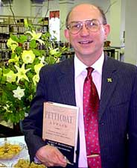
Dr. John Marszalek “Sherman: Myth and Reality”; Dr. Marszalek will discuss General Sherman's reputation in the nation both from negative and positive perspectives, presenting the facts about one of the most controversial individuals of the Civil War. To the average American, William Tecumseh Sherman is a one-dimensional figure. His image is that of the remorseless destroyer of southern homes, a merciless brute, an unfeeling bringer of fire and sword to the interior of the Confederacy. Even the most popular photograph of him, though hardly the only available one, seems to show such a person: a disheveled, hard, cruel soldier with a stare in his eye that is disconcerting even across the centuries. But, of course, Sherman was much more than that. Deep-feeling, insecure, and dogged by failure, he rose to be one of the most successful and influential general officers in the Civil War on either side, and went on to further military success after the war. Dr. Marszalek will take us through all of this.
Dr. John Marszalek
A US Army Vietnam veteran, Dr. Marsalek is a graduate of Buffalo’s Canisius College and Notre Dame, and taught for five years at Gannon University in Erie, PA before going to Mississippi State University in 1973 where he became a W. L. Giles Distinguished Professor of History in 1994, and Emeritus 2002. He specializes in the American Civil War, the Jacksonian Period, and race relations, and is the author or editor of fourteen books including prize-winning biographies of William T. Sherman (Sherman: A Soldier’s Passion for Order), Henry W. Halleck (Commander of All Lincoln’s Armies: A Life of General Henry W. Halleck), and Johnson C. Whittaker, one of West Point’s first black cadets. In 1999, Canisius College named him a distinguished alumnus and in 2002, the Natchez Literary and Cinema Celebration awarded him the Richard Wright Literary Award (life-time achievement by a Mississippi author). In 2004, the Mississippi Historical Society presented him with its highest award, the B.L.C. Wailes Award for national distinction in history. A member of the Board of Advisors of the Lincoln Forum and the Lincoln Prize, he became the executive director and managing editor of the Ulysses S. Grant Association in 2008, oversaw its move that year to the Mitchell Memorial Library Mississippi State University and its 2012 dedication as the Ulysses S. Grant Presidential Library.

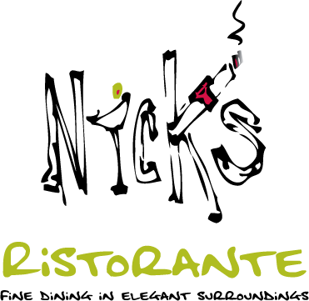
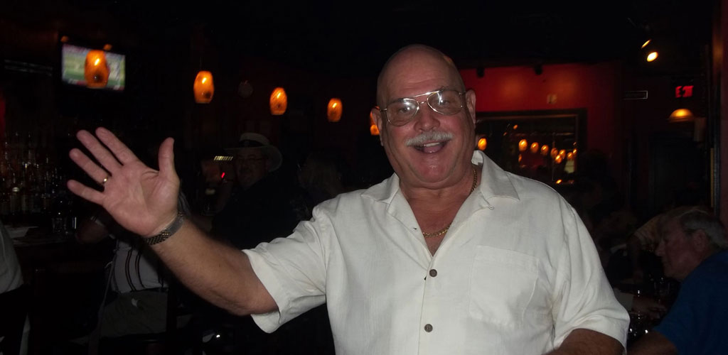
Let’s all go to Nick’s
Nick’s Ristorante remains the #1 steakhouse in North Alabama and now has the Best Chef in the Valley as voted in The Planet.
Our friend Nick of Nick's Resturante
In the event a scheduled meeting must be canceled, visit the website www.tvcwrt.org for a detailed update no later than 3:00 P.M. on the day of the meeting. A cancelation will only be for weather or if the Elks Lodge has an unexpected facility issue that requires closure. The board will not attempt to contact members.

Looking for Used Civil War Books; Look at the selections in the Library book store. Titles for as much as $4.
Former President and Charter Member of the Round Table: Brian Terrance Hogan has died;
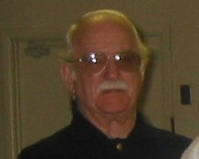
Comments from Mark Hubbs member of the Round Table and former Preservations Officer
Brian Terrance Hogan
Former TVCWRT President
"Brian was there from the beginning. When the organization was first conceived he was one of the first to come forward and became a charter member with our first meeting at the old Madison Town Hall. Brian was a stalwart proponent of the Round Table and fostered its growth and expansion from the early days at Quincy's in Madison to Shaver's Book Store for many years and finally to our current location at the Elk's Club. His 10+ years as President guided the Round Table and formed it into the robust historical and educational organization that it is now. It is safe to say, that the Tennessee Valley Civil War Round Table would not be what it is today, without the leadership that Brian Hogan provided to it through the years."

Editor
Brian’s health was troubling for several years yet he remained an avid advocate for preserving the history of the Civil War and when the Round Table passed the threshold of donating $10,000 to preservation he was the first to cheer. His advocacy did not stop at preservation, when we conducted our first symposium over 5 years ago he got out of his sick bed to participate. He was a dedicated research specialist and a close collaborator with Renee´ Pruitt, while she headed up the Archives at the Public Library, Jacque Reeves another prolific writer, and there were others. Much of the local Civil War research reflected in publications over three decades have contributions researched by Brian. And, each time we discussion preservation I recall a public debate between Mark and Brian regarding the options of the supporting the preservation of an Alabama Regiments battle flag or the hallowed ground of a battlefield. I don’t recall who won the debate but Brian led a small and loud constituency dedicated to preserving battlefields. We have not seen him at a meeting for a long time but he is in the room all the same.
Brian’s Obituary:
Brian Terrance Hogan (Aug. 3, 1933 - Feb. 28, 2017), age 83 of Huntsville passed away on Tuesday, Feb. 28, 2017. Mr. Hogan is survived by his wife; Susan Hogan, two daughters; Juli Hogan-Valley, Kathleen Horak; son, Devin Sean Hogan; two grandchildren, Kaitlin Horak and Brian Horak. Mr. Hogan was a native of Ashland, WI, and a resident of Madison County since 1978. He was the founder and past president of the Tennessee Valley Civil War Round Table, a member of The Elks Club and The Huntsville Historical Society. He was an avid Green Bay Packer fan his whole life. He was a veteran of the U.S. Navy during the Korean War. In lieu of flowers the family requests donations be made to Huntsville-Madison County Library, 915 Monroe Street SW, Huntsville, AL 35801.

Volunteers Needed! We are an all-volunteer organization that depends 100% on its members performing various tasks, and we need your help. There are several critical Board positions opening this year –

Programs Officer – Kent Wright has announced he is stepping down from this position effective immediately with regard to new speakers; he will follow through with those he scheduled. John Scales is filling in for him pending the appointment of a permanent replacement. The position seeks out, contacts, and arranges for speakers for our monthly meetings and for special events. You’re not alone but you are the lead. This position plans, prepares, organizes, schedules, and coordinates TVCWRT speakers, maintains a TVCWRT activities calendar, assists program speakers with preparation, and coordinates and serves as the TVCWRT representative to speakers and/or their sponsoring agencies. John Scales will continue developing field trips. Similarly, Jodi Stephens, our Special Events Officer, will lead the development, planning, and execution of those activities (assisted by the Programs Officer and others, as needed).

President – John Mason will be stepping down at the end of this program year (November). The position presides at the regular meetings and Board meetings, and generally coordinates and supervises the affairs of the TVCWRT.

Vice President – Emil L. Posey will step down at the end of this program year (November). The position generally supports the President. In the absence of the President, the VP performs the duties of the President and any special duties assigned by the President.

Communications Officer – Marjorie Reeves stepped down from this position two months ago; Emil is “Acting” since then. The position coordinates external TVCWRT communications, including, but not limited to, publicity for programs and other TVCWRT events in various media (flyers, newspapers, radio and television public service announcements, etc. as appropriate).

We also need a Marketing Director. It is a new position with responsibilities to guide the Round Table to increase membership and market programs to that end. It will involve developing, implementing and managing ways to understand our audiences in the Tennessee Valley, and to better promote the RT, our products, and our services to those audiences.
Prior experience with activities related to these positions would be helpful, none require prior experience or training as a prerequisite. The only qualifications actually needed are enthusiasm and a willingness to serve. Current and past Board members will advise as you settle in and get familiar with the tasks and rhythm.
Again, we need your help! Please contact any Board member if you are interested. If you don’t step up to help the organization, who will?

Help us advertise!

Are you on Facebook? Twitter? Or our web page?
If you are, “Friend” the RT. Then, when you receive FB notices of RT meetings and other events, “Share” them with all of your other friends (and ask them to do the same).
Also, do you have a Twitter account? If you do, “Follow” Emil Posey.
Then, when you receive his tweets of RT meetings and other events, re-tweet them so all that follow you will be informed (and ask your followers to do the same).

Mark Your Calendars:

Huntsville-Madison County Historical Society general membership meeting

March 12, Sunday, 2:00 – HMCP Library, Main Auditorium - Free
Speaker is John Rankin, local historian and preservationist, who will present an overview of the historical collection of Dr. Frances Cabaniss Roberts, stored at the UAH Salmon Library's Special Collections archive. He will also illustrate the process of digitization he uses, and the resultant evolving database developed by Deane Dayton to make the collection searchable on-line. Upon conclusion, he will list a few of the interesting case examples, allowing for audience selection to see the details of the data -- all in a Power Point presentation. Rankin retired after a 31-year professional engineering and management career with Boeing.

Ranee´ Pruitt Award for Excellence in Historic Preservation in Huntsville & Madison Co. Don’t miss this opportunity

March 22, Noon, Huntsville Country Club - $20 for lunch – Deadline for registering: Mar. 15
Keynote speaker: District 3 Senator Arthur Orr, Chairman, Alabama Bicentennial Commission, who will be introduced by Huntsville Mayor Tommy Battle. This program is open to all area historians, spouses, their friends, and all area elected officials. For a registration form, contact John Allen via email at jha@knology.net, or call 256-539-5287.

Beer, Bourbon and BBQ Festival at the Roundhouse

Saturday, August 19, when the Round Table will host a Beer, Bourbon and BBQ festival at the Roundhouse Depot as the kickoff of Huntsville’s celebration of Alabama’s Bi-centennial 1817-1819. More about it as details develop; Jodi Stephens already has planning well underway, and it looks to be fantastic!

Ranger Jim Ogden Friend of the Round Table to Receive an Award

On Tuesday 21 March, the U.S. Army will recognize Ranger Jim Ogden who has been the National Park Historian at Chickamauga for years, with a medal for outstanding civilian service and a certificate from the Commandant of the U.S. Army Command and General Staff College.
Jim has worked closely with the Army for over 30 years assisting in the conduct of educational programs such as staff rides (not “tours”). When the Army’s Command and General Staff College reinstitutes staff rides in the early 1980’s, Jim Ogden played a significant role in helping “stand the program up”.
Jim is passing through Huntsville in the morning of 21 March (a Tuesday). It offers one of the few opportunities for him to be awarded his medal and certificate with people who actually know him and have benefited from his knowledge. The exact time of the ceremony is still being determined but it will likely be about 10am.
Since Jim has presented to our Round Table and worked with a number of members, we would like to ask if we could have as many as possible meet at the Veterans Memorial Museum on Airport Road to honor Jim in a short ceremony. John Scales will present the award.

Round Table Ride to Stones River
This year the annual field trip will be to the Stones River Battlefield. The date for the trip has been coordinated with the Alabama and Auburn Football programs, and they will not schedule a home game on the 28 October. Jim Schroeder, the park’s highly regarded civilian volunteer tour guide, has recommended an itinerary. Stay tuned for addition details.
The 2017 Photo Contest

The 2017 Photo Contest is on. Don’t be afraid. A team of professional photographers judge all the photos and rely on standard elements to judge the quality of the photo. The Members choose what they like and seldom do the two agree. Last year we only had one member submit photos, and she won. Other members have won too. But, to be clear your great photo of your spouse leaning against a canon at Shiloh with that shinny new Mercedes clearly visible in the background will probably not get you a prize. But, it can be fun to find an angle that expresses a sentiment regarding your visit to Shiloh and what better way to remember than to take home a winner’s certificate.

The TVCWRT Approved Reading List

A feature of our education program on the Civil War is the TVCWRT Approved Reading List. Take a look at www.tvcwrt.org reading list under education. Click on Education and the recommended reading list. If you know of a book that meets the criteria, send me the title with a description of the book that explains why you think it should be on the list in 500 words or less. arleymccormick@comcast.net

Board Reports

Programs: acting programs director; John Scales

April 13, 2017: Andy Hall, “Captain Davis and the Yankees Blockade Running on the Texas Coast”
May 11, 2017: Michele Butts, “Galvanized Yankees”
June 8, 2017: Art Candenquist, “Did Anyone REALLY Know What Time It Was? The Lack of Time Standardization and Its Outcome on Many Battles”
July 13, 2017: Brian Steel Wills, "The Softer Side of Forrest"
August 10, 2017: Whitney Snow, “Guntersville's Teenage Civil War Diarist, Catherine Fennell”
September 14, 2017: Philip Leigh, “Confederacy at Flood Tide”
October 12, 2017: David Lady and John Scales, "Stones River"
October 28, 2017: Jim Schroeder, Field Trip to Stones River Battlefield
November 9, 2017: TBD

Membership: Kevin Rodriguez

The goal of the Round Table is to increase membership. We consistently, over the past few months, enjoyed a membership roll of just over 140. That is impressive. As of this printing we reached the 52% of membership renewals. Mail your dues to the Round Table, or relax and go to www.tvcwrt.org, hit the Pay-pal key and stay out of the rain and weather, or see Kevin on Thursday night. It would be a plus if you brought an acquaintance and helped us reach the 160 mark in membership.

Note that those not renewed by the end of the March meeting will be moved from the “active” member listing to an “inactive” list and, until renewed, will no longer be eligible for member benefits (such as being on the mailing list for the newsletter and other RT business, drawings for Nicks at our meetings, and so forth). Renewal rate remains $30 for the year (no deductions for tardiness).

Please renew your membership if you haven’t already done so! Thanks!

TVCWRT Features

Book Review

Lincoln’s Greatest Journey – Sixteen Days that Changed a Presidency, March 24-April 8, 1865 by Noah Andre Trudeau Reviewer: Ricardo Jaramillo, Tennessee Valley Civil War Round Table

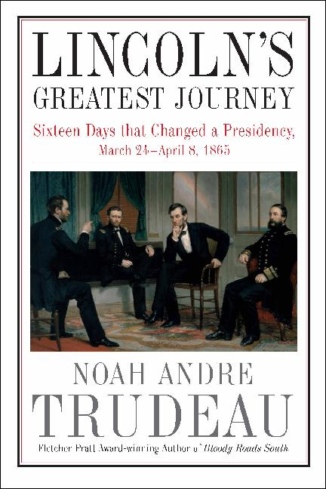
Lincoln's Greatest Journey is a must-read book and a plus for a devout Lincoln follower’s library.
Trudeau states he will provide ‘new' information not previously written. New in the sense that of the more than 16,000 volumes of Lincoln writings written to date, new information will show how Lincoln became a better national leader just days before his assassination. While this reviewer has not read all these volumes, it is apparent that the author succeeded in providing something new and relevant. Lincoln’s 16-day journey from Washington DC to City Point, Virginia, started March 24, 1865, and ended April 8, 1865. A short 265-mile route via the Potomac River, Chesapeake Bay, and the James River placed the President within earshot of cannon and gunfire from the Confederate capital of Richmond, Virginia, and the Confederate stronghold Petersburg, Virginia. Trudeau wrote this story using conjecture and facts not previously published. Fellow family travelers, Mary Todd, Tad, and Robert’s, everyday activities and outbursts were provided to bring out the collateral emotions the President felt and had to deal with just a few miles from the enemy. Trudeau provides details of guest activities, to include Commander and dignitary meetings that occurred on the River Queen, the side-wheel steamer where the Lincolns and company lodged during this journey, and the USS Bat assigned to escort the President. Trudeau details how Lincoln’s war bulletins to the press during this time proved to be what the Nation needed and provided a picture of a President willing to place himself within miles of the enemy to show his commitment to his country. These and many other small details evolve to become a greater story that enticed this reviewer to keep reading anxiously with high expectations. Trudeau’s title, Lincoln’s Greatest Journey, is reminiscent of how he planned to tell this great story like never previously described before.
Trudeau laments that Lincoln’s state of mind was not at its peak before March 25, 1865. The result of the 16-day journey was a Lincoln no longer controlled by events, but rather one focused on leading the country out of this horrible war. Like no other author, Trudeau eloquently writes how Lincoln became a greater national leader during these 16 days. Trudeau accomplished this through his thorough research and even discounted facts of previous author's writings.
Books by many authors tell of Lincoln's mental and political prowess in an as-a-matter-of-fact manner. Detailing events in this way leads the reader to skim through these books and arrive at few or no new conclusions. Using conjecture, Trudeau interlaces personal character details and additions of period related elements so that the reader is enticed to continue reading in earnest. This reviewer attests to this: If one skips or skims through pages, missing a significant part of the story might occur.

Little Round Table Report: David Lady

"The Little Round Table meeting of 23rd Feb, 2017:
A large group of our regulars came together that Thursday to learn from John Scales, our resident Nathan B. Forrest expert, on the operations of Forrest and his cavalry during the Army of Tennessee's last offensive of the war, as General Hood led the army against Nashville in the autumn of 1864, attempting to recapture Tennessee's capital and cause the main Federal armies to cease their offensives against Petersburg and Savannah.
John described how Forrest, with a smaller and less well-equipped force of cavalrymen, drove away the Federal cavalry and permitted General Hood to actually place his army between Nashville and the Federal defenders farther south around Columbia, Tennessee. This permitted the members to enjoy a lively discussion about what actually happened during "The affair at Spring Hill," when the Federals marched all night to pass the Confederates, sometimes passing within only hundreds of yards from the strangely inactive Confederate infantry.
Forrest's attempt to provide Hood with an alternative to assaulting the Federals in their fortifications at Franklin, and the little-known attempt by Forrest to seize Murfreesboro and the accompanying Battle of the Cedars were also reviewed, as all considered just why Hood would employ his finest cavalry leader in 'side-shows' while the main Army suffered utter defeat in the two-day Battle of Nashville.
Finally, John showed us General Forrest's brilliant tactics and inspired troop leading as he commanded the rear guard that shielded Hood's defeated men from the pursuing Federals during the bitter retreat south of the Tennessee River.
Thank you John Scales! It was a very good session, and thanks to all who came and joined in the conversation.
The Little Round Table will meet at 6:30 PM, 23 March, 2017 at the Elks Lodge. Jeff Ewing will lead our discussion of the disputed Presidential Election of 1876, and the Compromise of 1877 that brought the Reconstruction Era to an end. The Republican candidate trailed in the popular vote, but three southern state electoral votes were disputed between the two parties. A special commission was appointed to settle which of the two candidates won those electoral votes. Deals were made, regular army units ceased attempting to assure civil rights (and suppress local control of some affairs) in the south; Rutherford B. Hayes was assigned those electoral votes and became Americas nineteenth President. Did the rule of law prevail? Was justice done? Come and enjoy an evening of sharing and learning."

The 2017 Little Round Table Topic Schedule

March 23 -The Compromise of 1877 and the end of Reconstruction- Jeff Ewing
April 27 - Political Generals, both Yank and Reb- David Lady
May 25 – Knights of the Golden Horseshoe, and other Northern Copperheads- Arley McCormick
June 22 - Braxton Bragg- Ed Kennedy
July 27 – William Rosecrans-Ed Hennessee
August 24 -"States Rights Governor," Joseph E. Brown of Georgia– Larry Bayer
September 28 – Awards, Decorations, and other Honors, Confederate-John McGuire
October 26 – The Most Noteworthy Army Corps Commanders- John Scales
December 14 - General Benjamin Butler-Emil Posey

Participation in the Little Round Table is restricted to Members and invited guests. It is scheduled for the 4th Thursday of the month 6:30 PM at the Elks Lodge.

Thanks You Mr. President, you provided us with a very interesting evolution of Lincoln’s evolution from saving the Union to removing slavery from our midst. Great Job, thanks from all of us.

The TVCWRT Board of Directors

John Mason, President

Emil L. Posey, Vice President

David Lady, Secretary, Little Round Table Coordinator

Kent Wright, Program Officer

Ricardo Jaramillo, Treasurer/WebSite coordinator

Emil L. Posey, Acting Communications Officer

Kevin Rodriguez, Membership Officer

Arley McCormick, Newsletter Editor

Jodi Stephens, Special Events Officer

George Mahoney, Sergeant-At-Arms
Robert Hennessee, Preservation Officer

ADJUNCTS

Mark Hubbs, Social Media Coordinator, Former Preservation Officer and co-founder
John A. Allen, Former President

John Scales, Former President and Field Trip Coordinator

Carol Codori, Former President

Kathi Arnould Paul, Voice of WLRH

RT Public Service Announcements

Marissa Jones, Website Manager

